**Create Form Login With VB.Net 2013**

1. Create New Project

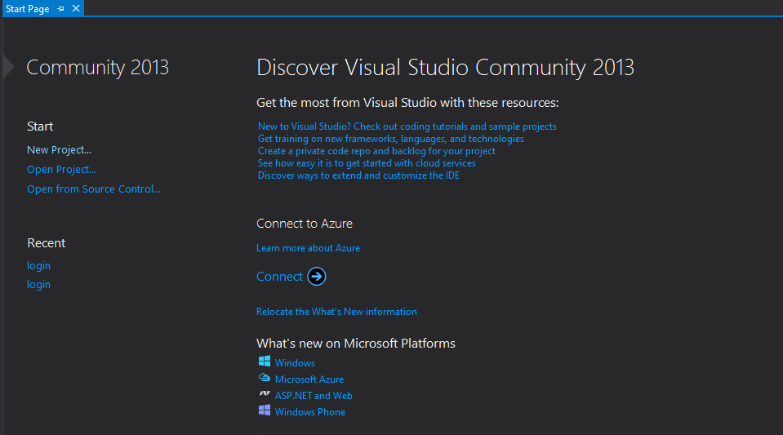

1. Select Visual Basic And Use Windows Form Aplication ( Name Your Project ), inf Textbox Name

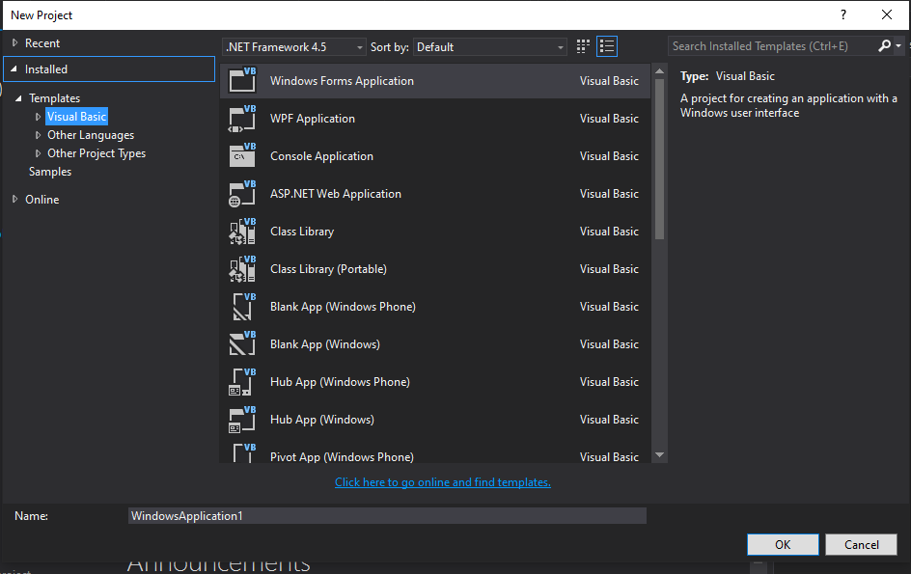

1. Create and Design Your Windows Form With ( 2 Textbox), (2 Label), (1 Button ), Rename Your Textbox with Your Creatifity

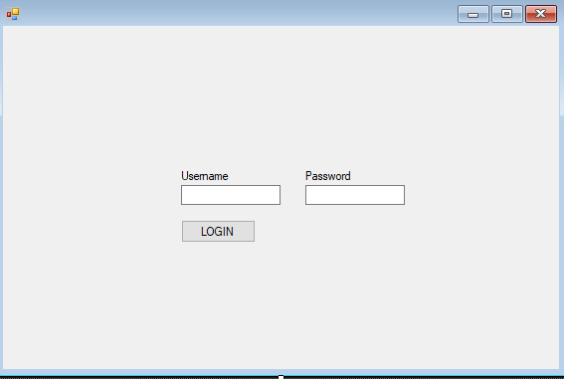

1. Lets Code With Double Click Button Login

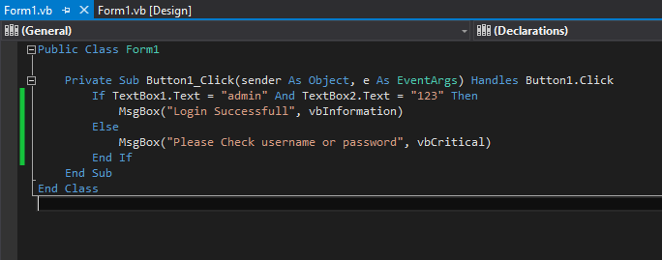

Create Condition if textbox in form login not equal to value textbox in code

1. Run Your Application press F5

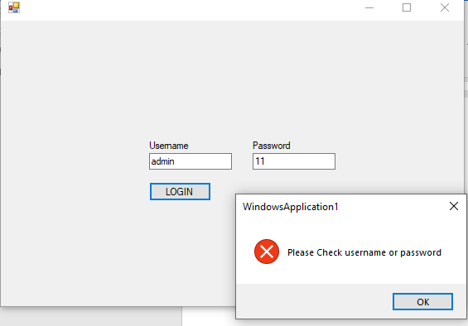

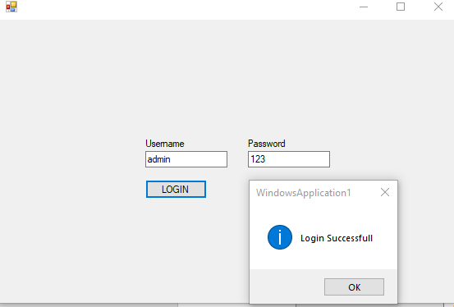

**DONE**